**ELECTRICAL ENGINEERING**

**YEAR 3**

**NSHIMIYEMUNGU Isaac 19RP05378**

**TUYISHIME Jackson 19RP08499**

**TOPIC: TURNING ON BUZZER BY USING ULTRASONIC SENSOR AND AVAIL NOTIFICATION THROUGH GSM**

1. **ABSTRACT**

House is a basic human need for shelter and a place to store some personnel important things. Usually, home security generally only depends on the gate and fence. This type of security is still risky since it does not offer a full security that every people can rely on since thieves may climb over that fence and enter the house. In addition to this, gate keepers are hired to oversee those climbing thieves, but also, they may fall asleep. With the development of technology nowadays, a number of security systems are designed to protect homes and available belongings. In this paper, we are intended to employ a new design technique and develop a low-cost home security and safety system. This kind of security system is more reliable because it can monitor or control intruders entering or coming near your home/room while you're available or not available by using an ultrasonic sensor via distance measuring and notify you wherever you are by using a simple GSM modem controlled by an Arduino uno board, after turning on an alarm system to notify you while you're near whenever there is a change in the set distance. This system makes the user feel comfortable in his/her activities without worrying about the safety of his/her home.

1. **PROBLEM STATEMENT**

After studying and understanding the uses, working and applications of some electronic devices, we sat together with my colleague and think. We saw the problem of insecurity at homes reaching to another level due to poor security handling procedures. We have seen also that sometimes a person may have a private room in which he/she does not want anyone to come near it, then we wondered this question, 'how can we simply handle the problem of this unstable and unreliable security?'. we finally come up with an idea of designing a simple home security monitoring system using an Arduino uno board, GSM Module and an ultrasonic sensor as the main components.

1. **BLOCK DIAGRAM**

**ULTRASONIC SENSOR**

**MICROCONTROLLER**

Atmega 328P

**GSM MODEM**

**BUZZER**

**Description**

The action is started by the ultrasonic sensor which detects the position of nearby people. This is done by sending out a high frequency sound pulse, and then times the time it takes for the echo of the sound to reflect back according to the distance stored. When the set distance is changed, it means that something or someone is coming near the door. After receiving that echo sound which will help it to measure the change in the distance, the signal is transmitted to Atmega328 microcontroller which works as an interface or coordinator of the system. A buzzer (alarm system) is turned ON via the output pins of the Arduino uno board for a time to notify the nearby people. After the set time, a microcontroller will send an SMS to the owner/user through GSM Modem to notify the owner that the set distance is changed.

1. **CIRCUIT DRAWN IN FRITZING**

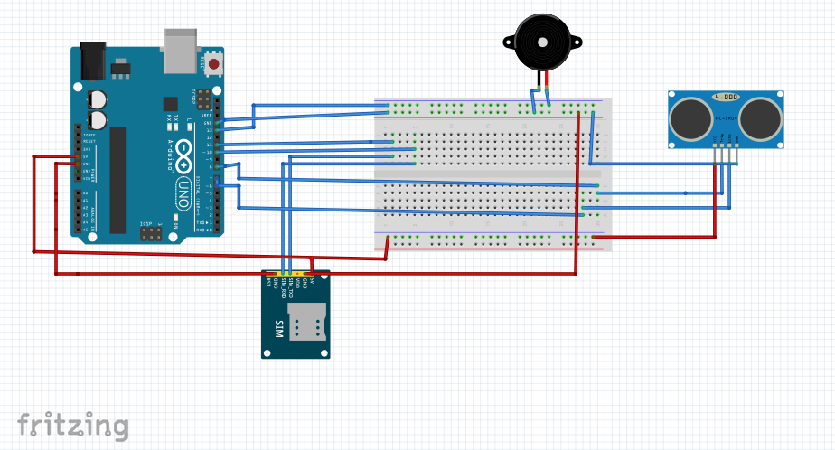

1. **CIRCUIT SIMULATION IN PROTEUS**

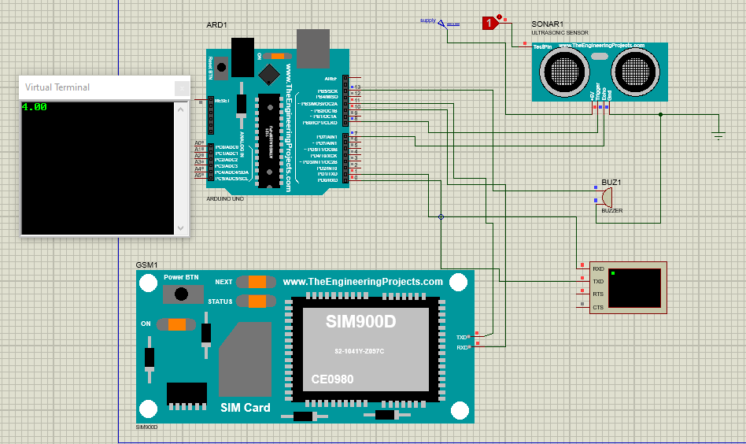

1. **CODE**

#define echo 7 // connect echo pin to arduino D7 (ultra sonic sensor)

#define trig 8 // connect trig pin to arduino D8 (ultra sonic sensor)

#define led 13 // optional

#define thresholdDis 20

long duration; // store time duration of sound travel

int dis; // store actual distance to object

#include "SoftwareSerial.h"

SoftwareSerial mySerial(10, 11); // RX, TX

bool flag = 0;

void setup() {

// Open serial communications and wait for port to open:

Serial.begin(9600);

while (!Serial) {

; // wait for serial port to connect. Needed for native USB port only

}

// set the data rate for the SoftwareSerial port

mySerial.begin(9600);

pinMode(echo, INPUT); // echo pin work as input

pinMode(trig, OUTPUT);

//sendSMS("0760154020", "Hi, Hello.this is me :)"); // send msg one time

}

void loop() { // run over and over

float disInCm = checkDistance();

Serial.println(disInCm);

if ((disInCm > thresholdDis) && (flag == 0)) {

flag = 1; // prevent sms sending continusly

sendSMS("0788401818", "Max distance detected. now distance is " + String(disInCm) + "Cm"); // send msg one time

}

if (disInCm < thresholdDis) {

flag = 0; // clear flag for next event

}

delay(100);

}

int checkDistance() {

digitalWrite(trig, LOW);

delayMicroseconds(2);

digitalWrite(trig, HIGH); // triger signal as datasheet

delayMicroseconds(10);

digitalWrite(trig, LOW);

duration = pulseIn(echo, HIGH);

dis = duration * (0.034 / 2.00); // speed of sound

return dis;

}

void sendSMS(String mobileNUmber, String msgBody) {

mySerial.println("AT"); // check connection

readResponse(); // read modem response

delay(1000);

mySerial.println("AT+CMGF=1");// SET MODULE TO TEXT MODE

readResponse(); // read modem response

delay(1000);

mySerial.println("AT+CMGS=\"+250788401818\"\r");

readResponse(); // read modem response

delay(1000);

mySerial.println(" distance is changed"); // enter msg

delay(1000);

mySerial.print((char)26); // send msg

delay(1000);

}

void readResponse() {

//simple function for read modem response. we will check work or not

delay(1000);

String response = mySerial.readStringUntil("OK");

Serial.println(response);

}

1. **CONCLUSION**

After implementing the system, we realized that the system performs the desired work as expected with high operating speed, efficiency and low cost as everyone can afford it.